1. How do you use the &quot;cp&quot; command to copy a file named &quot;file.txt&quot; from the current

directory to a directory named &quot;backup&quot;?

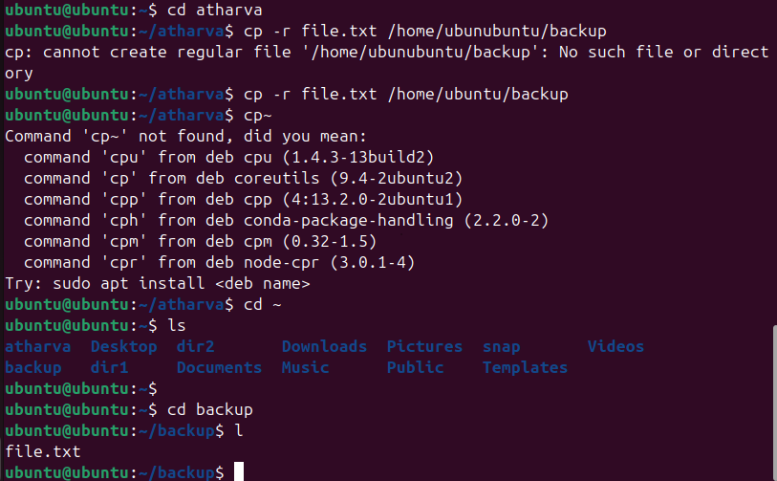

2. What is the difference between the &quot;rm&quot; and &quot;rm -r&quot; commands in Linux?

rm is used to delete individual files, while rm -r is used to delete directories and their contents recursively.

3. How do you use the &quot;mv&quot; command to rename a file named &quot;oldname.txt&quot; to

&quot;newname.txt&quot;?



4. What does the &quot;pwd&quot; command do in Linux?

The pwd command in Linux stands for "print working directory." Its purpose is to display the full, absolute path of the current directory you are actively working within in the terminal.

5. How do you create a new empty file named &quot;newfile.txt&quot; in the current directory using the command line?

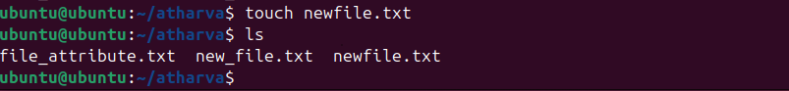

6. How do you rename a file named &quot;oldname.txt&quot; to &quot;newname.txt&quot; using the command Line?



7. How do you remove a file named &quot;file.txt&quot; from the current directory using the command line?

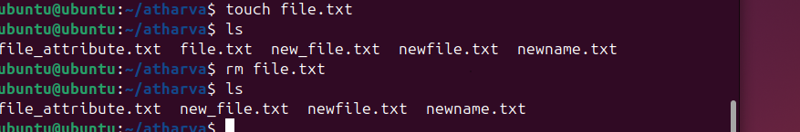

8. Use a command to show the current working directory



9. List the directory contents in the short and long format

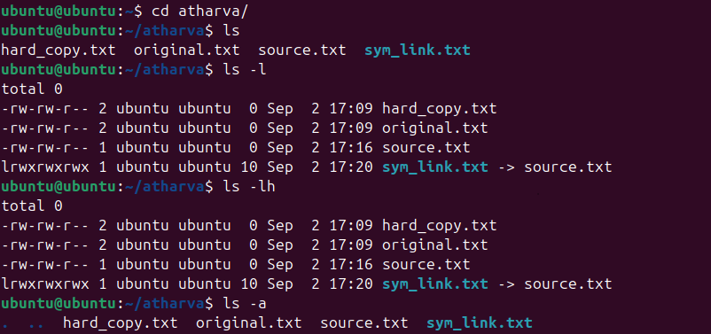

10. Explore attributes given in long format e.g. file type, file permissions, file size, file

owner etc.



11. List all files along with hidden files in the current working directory.



12. list only hidden files in the directory

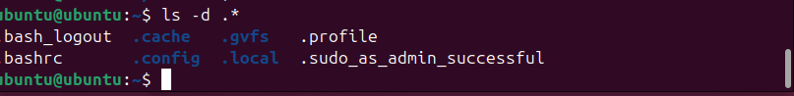

13

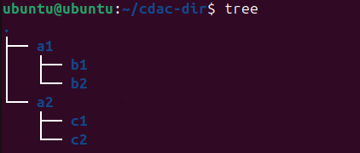

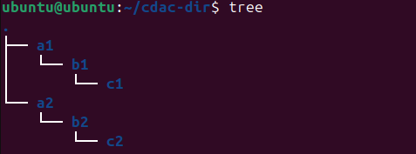

15

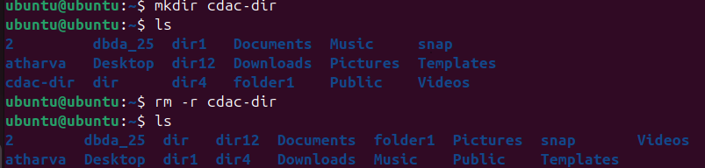

17

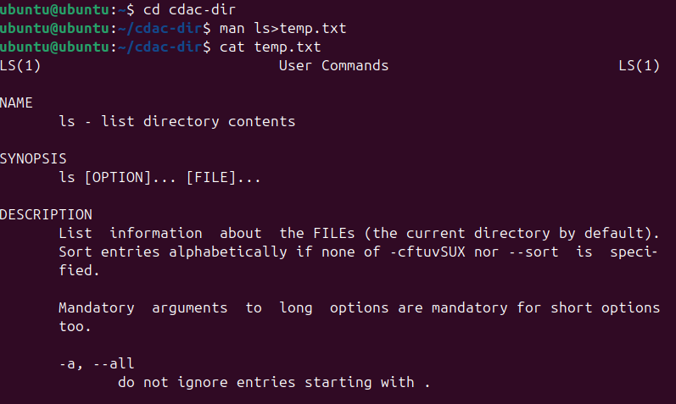

18

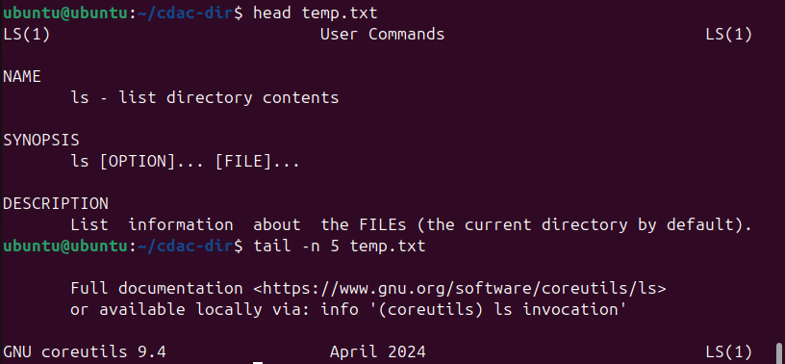

19

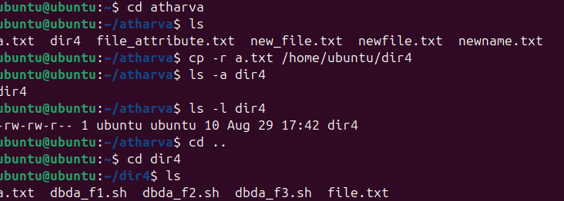

20

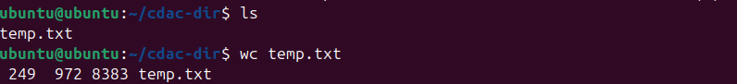

21

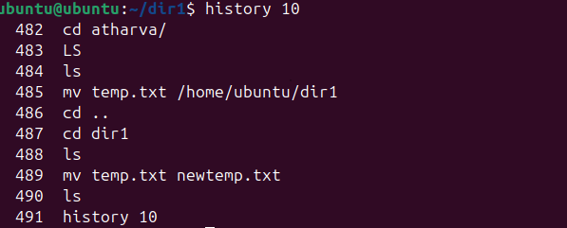

22

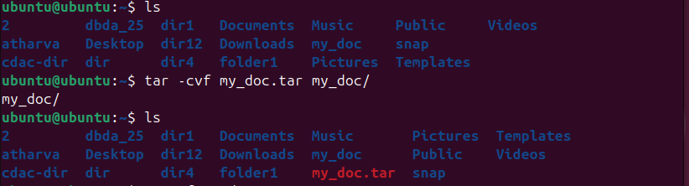

23

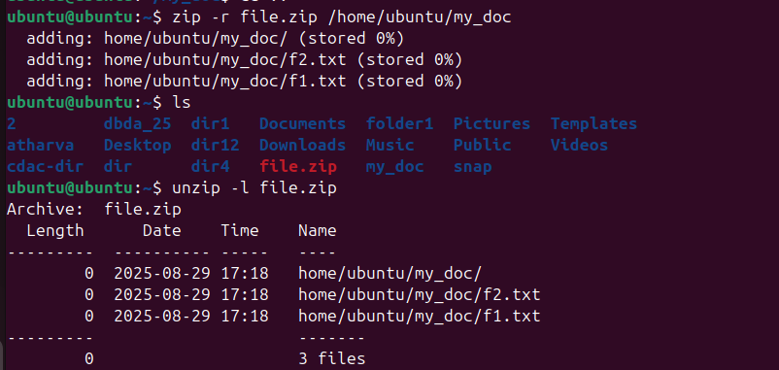

24



25



26

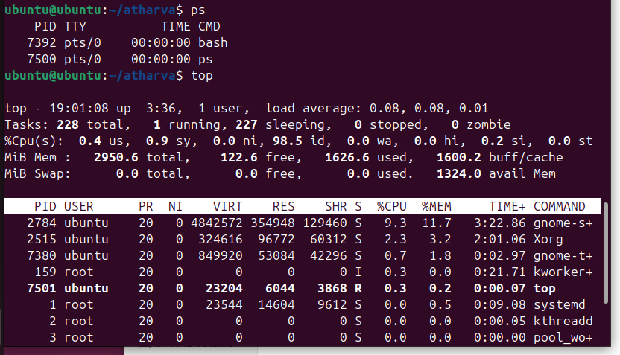

27



29

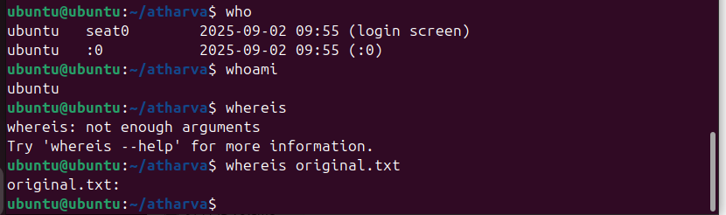

30

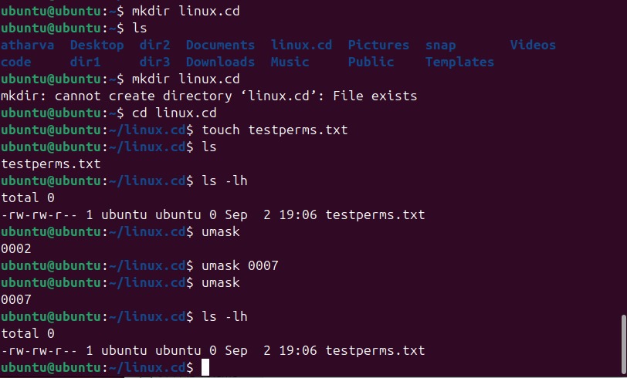

31



32

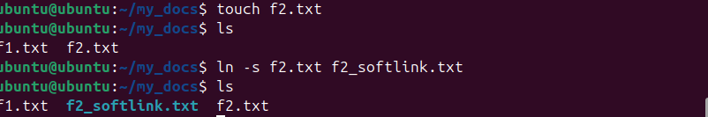

33

34

35

36

37

38

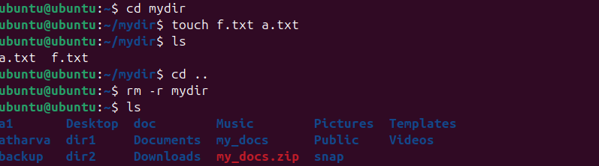

39

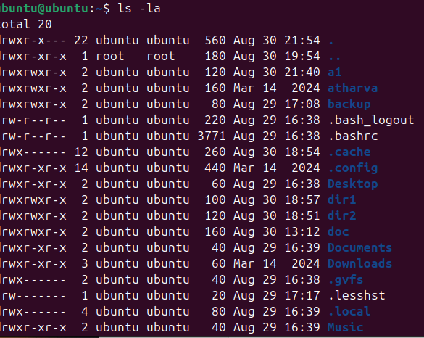

40



41



42

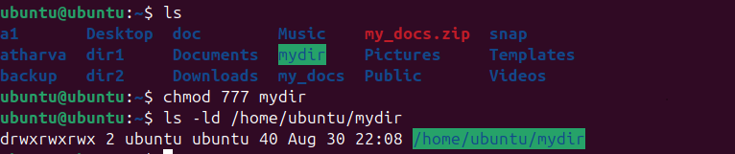

43

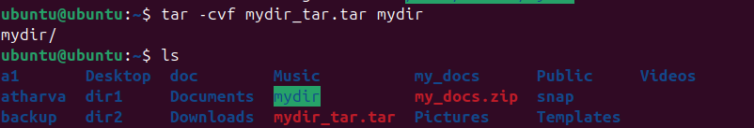

44



45



46

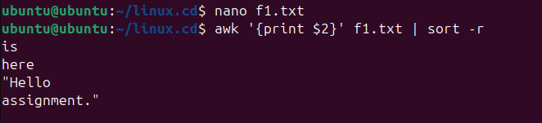

47

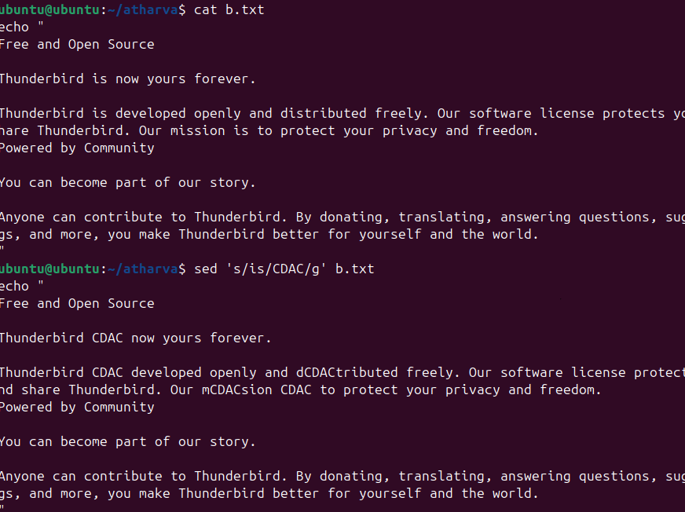

48

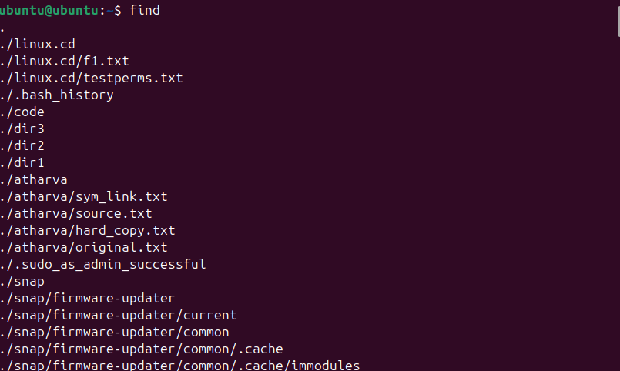49

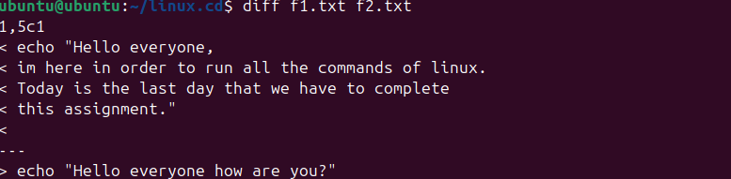50

****

51

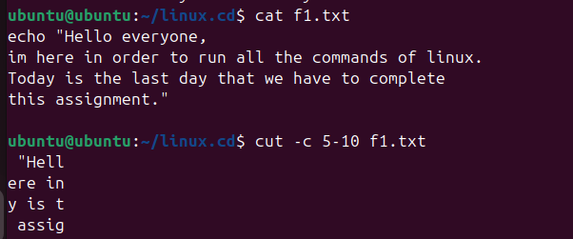

52

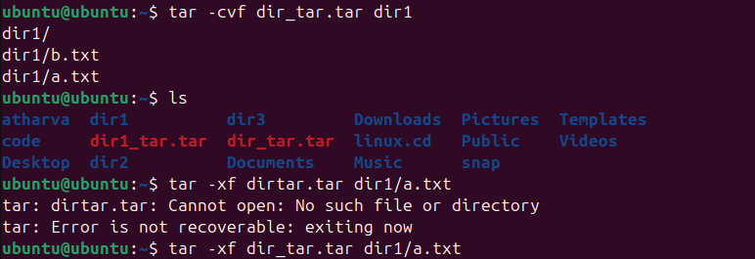

53

